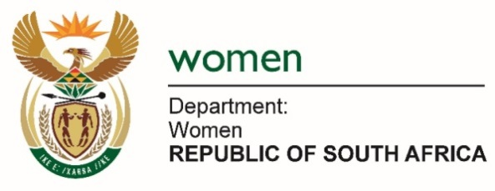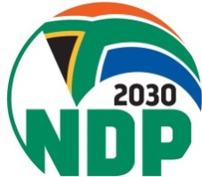

Commission on the Status of Women (CSW63)

Side Event
Topic: Sharing of Best Practices on Social Protection Systems in the SADC Region

Date: 13 March 2019
Time: 11:30 AM-12:45 PM
Panelist: Ms. Bathabile Dlamini,
South African Minister of Women
Venue: Ex-Press Bar - GA Building
Organiser: SADC

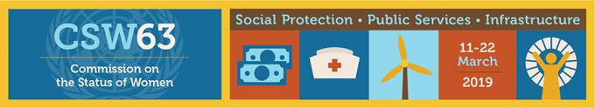
The 63rd session of the Commission on the Status of Women (CSW) takes place under the theme “Social protection systems, access to public services and sustainable infrastructure for gender equality and the empowerment of women and girls”.
South Africa is fully committed to the South African Development Community as well as realising Agenda 2063. Our national targets are informed by Agenda 2063 and we continue to draw on knowledge and expertise within the SADC Member Countries to end gender equality and empower the girl child.
South Africa is a signatory of several intervention conventions: International Convention on Economic, Social and Cultural Rights. One of the socio-economic rights contained in South Africa’s Bill of Rights is the right to social security (S27(1)(c) of the Constitution). The state is obliged under section 27(2) to ensure that this right is promoted and provided for. Convention on the Elimination of All forms of Discrimination against Women (CEDAW), Articles 11(1)(e), 11(2)(b) and 14(2)(c) supports the right to social security as espoused in the Constitution.

South Africa has made great strides and achievements in the area of social protection, access to public services and sustainable infrastructure. Our social protection system and access to public services and infrastructure is based on universal human rights and their progressive realisation. Human rights and progressive realisation are part of developmental processes guided by policies and legislation to respond to inequalities of the past and deeply embedded systems of patriarchy.
A financial model for social protection:
Esteemed guests,
The Social Assistance Act, 2004 regulates the administration and the payment of social grants. It describes who is eligible for grants and ensures that there are minimum standards for the delivery of social assistance. It also provides for the establishment of a body to monitor the quality of delivery: the Inspectorate for Social Assistance. According to the Act, the State must make money available for the following grants: a child support grant; a care dependency grant; a foster child grant; a disability grant; an older person’s grant; a war veteran’s grant; and a grant in aid. Chapter 2 (13) makes provision for the Minister of Social Development to provide social relief of distress to a person who qualifies for such relief as may be prescribed. This financial security system reaches over 17 Million South Africans, and mainly benefits women, girls, and in particular child-headed households.
The South African Constitution (Act No. 108 of 1996) enshrines the right of everyone in the country to have access to social security, including the right to social assistance, if they are unable to support themselves and their dependents. This right is enacted in the South African Social Assistance 2004 (Act No. 13 of 2004), which provides for the rendering of social assistance to eligible persons.
The White Paper for Social Welfare 1997 defined widely the parameters for the provision of social security or a social floor/net. In 2018, given the ever-increasing rate of unemployment, especially for women and young women, provision of social security by the state is a very critical function in addressing women’s poverty. Social security takes the form of cash provisions such as social grants or in-kind benefits such as food parcels, seeds, fertilisers and implements for sustainable and household farming/gardening; provision of free sanitary towels to indigent women and girls; free medical care in public health facilities for pregnant women and children up to 6 years; free condoms and other forms of family planning measures; free basic water and electricity to indigent households; free or No-Fee Schools for indigent children, etc.
South Africa’s social welfare system is fully funded by the South African government; and is highly gender-responsive. This social protection network has expanded considerably since 2002 to date, and it is subjected to an annual increase.

A number of grants provide a significant safety-net and social protection to women in the country.
Social grants contribute towards food security and reducing poverty in the country. The National Development Plan recognizes that reducing the cost of living is essential for broadening economic participation and eliminating poverty. According to the World Health Organisatioon (2011), in the period from 1999 to 2003, approximately 2.6 million South Africans received social grants and by 2007 this figure increased to 12 million. By 2018, 17.5 million people received social assistance. In 2018, 29% of the South African population was in receipt of a social grant. Child support grants have the bulk share of the distribution at over 12 Million beneficiaries.

Social Grants by year and sex of the recipient
The social security system in South Africa plays an important role in mitigating the impact of socio-economic challenges among female-headed households. It serves as a poverty measure and a protection measure to absent fathers in terms of child maintenance. It augments the pro-poor package of services offered to children from birth to the age of 18 years. It is a conditional cash transfer to the primary caregiver of children living in extreme poverty and thus serves to supplement rather to replace household income from employment. Moreover, households receiving social grants tend to live in communities eligible for access to other forms of social protection, including grants for public works in the form of extended public works and to boost agricultural development among resource-poor small farmers.

While women have always been higher than men as beneficiaries the proportion of women has been declining over time. For example, in 2003, 60% of women were social grant recipients compared to 53% in 2017.
South Africa’s Expanded Public Works Programme (EPWP) aims to create short term employment for the unskilled and at the same time create or improve existing infrastructure. The interface of the EPWP and early childhood development (ECD) as a social sector programme is a public good that reflects the social protection and infrastructure of the nexus. There’s more social protection interventions that seeks to go beyond the income-based welfare benefits to those derived from various types of social protection in line with Sustainable development goal (SDG) 5 and inter-linking SDGs.
South Africa recently made attendance at Early Childhood Development Centres compulsory for all children. This is part of our government’s plan to manage the development of the child at all stages to reach their full potential. This reaches to tertiary education where the National Student Financial Aid Scheme disburses over 2 Billion US Dollars to deserving students, the majority of which, are young women.
Our social protection system is redistributive in its focus and is based on the provision of a basket of goods and services. This includes income support through non-contributory social grants, free housing, free basic services at the local municipal level, free basic education, free health care services and the recently instituted free higher education for poor students in higher education. The Free Basic Services determined amounts of water, sanitation, electricity and the exemption from paying local taxes for poor households.
South Africa’s social protection systems are unapologetically geared towards the poor, which make up the majority of South Africa’s population. For the State to end multi-dimensional poverty, all policies and legislation must be gender-responsive and pro-poor.

The empowerment of women is a key factor in breaking the chains of gender-based violence and our interventions continue to work for the emancipation of women.
Thank you

