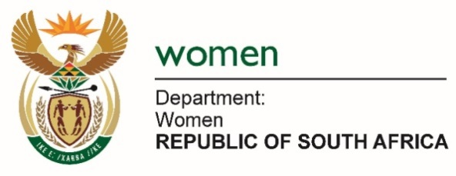

Commission on the Status of Women (CSW63)

Side Event
Topic: The Gender Effect of Parental Leave and Care Policies – Stronger with Dads Involved

Date: 13 March 2019
Time: 15:00 – 16:15
Speaker: Ms. Bathabile Dlamini,
South African Minister of Women
Venue: Conferene Room, ECOSOC Chamber
Organiser: Iceland (Office of Prime Minister)

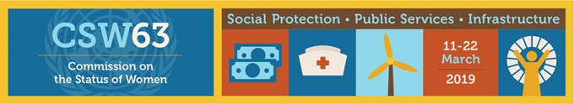

Excellency, Prime Minister of Iceland, Ms Katrin Jakobsdottir
Government of Iceland Representatives
Esteemed Guests invited to this Panel Discussion
Ladies and Gentlemen,
Allow me to first express my appreciation for the opportunity to share best practises between our two countries. This is indeed a unique interaction, as our countries house very different cultures but our commitment to the sanctity of the family unit as the heart of the nation remains an apex priority.
I also wish to recognise the work of Prime Minister Katrin Jakobsdottir in driving the Nordic Gender Effect which aims to promote gender equality under the realisation that a productive workforce cannot be an unequal workforce.
South Africa has made great strides in ensuring gender equality in the workplace through the Labour Relations Act and the Basic Conditions of Employment Act. A State instrument funded by Government is The Commission for Gender Equality which is a Chapter 9 Institution responding to cases of discrimination on the basis of gender and it also has the function to promote gender equality.
South Africa has adopted the White Paper on Families which has three priorities – To promote healthy family life; to strengthen the family unit, and to preserve the family.
However, we know that gender oppression and gendered roles and stereotypes begin in the family, in households. Our family life in South Africa was deliberately destroyed by apartheid. The combination of apartheid and patriarchy created sites of struggle within the household. Our challenge in South Africa is how to reconstruct family life and at the same time transform gender relations to ensure that there is shared responsibility within the family by men and women.
The forced migrant system of labour under apartheid resulted in fathers being separated from their families under the worst possible conditions to work on the mines. Spatial distances between sites of work and homes led to many children being raised in single-parent headed households. The impacts on black family life are devastating and the consequences are still visible today. Our policies and legislation recognise our history and also recognise the changing context that require us to redress the past while we ensure that men and women and the LGBTQ+ communities are able to live free from gender oppression, gender based violence and other forms of discrimination. How do we do this? We uphold the rights and responsibilities of all members of the family so that the bodily integrity, safety and protection of men and women is secured.
Our labour legislation reflects a move towards gender equality through leave arrangements for working people.
Programme Director,
South Africa recently extended paternity leave for fathers to 10 days. This allows for fathers to bond with their newborn children in a way that was never possible in the past. We are trying, through this measure to provide an enabling environment for men and women to share in the social reproduction process and care of human beings. It is also an attempt to legislate and normalise the shared responsibility for the care of children. South Africa places the wellbeing of the child at the centre and legislation to support the family unit shows this. Policies that ensure an enabling environment for the psychological development of the child are constantly being introduced. This requires the presence of both parents at all times. When fathers are playing a visible parenting role in the household and are part of decision- making on the well-being of the child then their actions shatter stereotypes that women are responsible for the care of children. This has the potential to normalise the care and responsibilities of fathers and male partners in the communities.
Shared parenting – men and women sharing the social care responsibilities, enables the burden of care on women to be reduced. Shared parenting by fathers and mothers debunks the idea that care is the domain of women.
However, poverty casts a long and painful shadow over the family lives of black women whose social reproductive work within the household is discounted, undervalued and not seen as adding monetary value to society. The majority of single-parent households are headed by women. In South Africa we continue to advocate for inclusion of unpaid care-work to be counted as a contribution to the economy. We need to quantify the efforts of women to reflect this contribution to our economy.
Programme Director,
Government cannot be expected to constantly step in for fathers who are mature enough to engage in sexual activity but not responsible enough to take care of their children. Fathers, absent by choice, remains a burden on government, but is a bigger burden on the emotional development of the child. As Government, we need to ensure that social protection systems contribute to the healthy development of the family unit, and children. We need to ensure that our social protection systems (particularly, education, health care, access to water and sanitation) are felt in communities.
In conclusion, South Africa’s labour legislation is sensitive to family responsibilities and makes provision for working hours, leave, family responsibility leave, compassion leave, and incentivises men to engage in child care. Our position is that fathers must play a positive role in the lives of their children and to not only be seen as providers, but nurturers.
We are focusing on education as a means to re-socialise boys and girls about gender roles so that our Constitution, our progressive laws and rights take root from an early stage. Changes to curriculum in schools are underway.

I thank you

