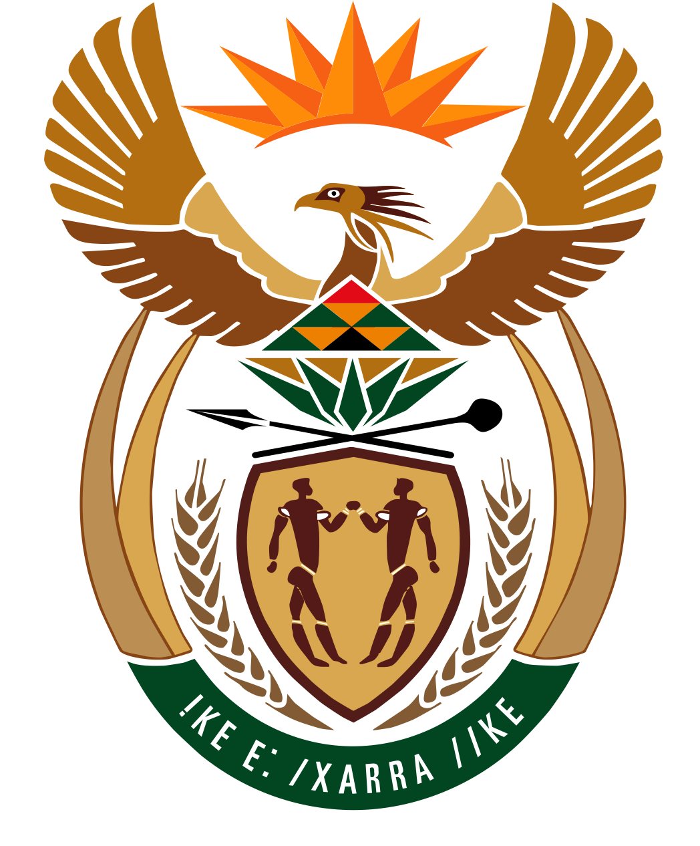

Budget Vote 20 Speech by Minister in the Presidency for Women, Youth and Persons with Disabilities
Honourable Sindisiwe Chikunga, MP

Thursday, 4 July 2025 @ 10:00
Room 46, Marks Building, Parliament of the Republic of South Africa, Cape Town
Theme: “From Mandates to Meaning: Advancing Inclusion through Law, Budget and Action”
- Honourable House Chairperson,
- Deputy Minister Honourable Steve Letsike,
- Chairperson of the Portfolio Committee Honourable Lizel Van Der Merwe,
- Honourable Members of the Portfolio Committee
- Women, Youth and Persons with Disabilities across our nation watching from home,
- Distinguished guests in the gallery and the library,
- Fellow South Africans,
Good Afternoon!
- INTRODUCTION
It is with great honour and privilege that I rise to table the 2025/26 Budget Vote 20 on behalf of the Department in the Presidency responsible for Women, Youth and Persons with Disabilities.
We gather in this House during a year of profound remembrance and responsibility. Seventy years ago, the Freedom Charter, proclaimed, “The People Shall Govern.”
Thirty years ago, we crossed the threshold of democracy, affirming that The People Shall Govern is not merely a historic slogan — it is a constitutional imperative.
This Budget Vote presents an opportunity to account — not only for what we have done, but for how far we have yet to go in realising the Freedom Charter’s demand that:
The doors of learning and culture shall be opened. There shall be work and security. The people shall share in the country’s wealth. There shall be peace and friendship.”
SECTION 2: STRATEGIC PRIORITIES FOR 2025/26 FINANCIAL YEAR
2.1 STRATEGIC FRAMING – “THE PEOPLE'S PRIORITIES MUST BE THE NATION’S PRIORITIES”
Chairperson,
We come to this House to affirm five constitutional imperatives:
- That the youth must rise as leaders, innovators, and builders of our economy.
- That women constitute the very foundation of our economy and national wellbeing.
- That persons with disabilities are not a 'special category' — but equal citizens, rights-holders, and co-architects of our democracy.
- That state machinery must not reproduce exclusion — it must serve as an engine of equality, and that
- Our public budgets are instruments of transformation for all of us. They must be gender, youth and disability responsive.

Therefore, honorable members, this budget vote is a call to action.
Importantly, our very existence as a department is informed by a realization by successive administrations that, despite the existence of other departments and their programmes, vulnerable groups require a dedicated catalyst to take extraordinary measures to rally all of government and all of society behind a cohesive transformation agenda that transcends just compliance. This is at the core of our mandate.
Our budget vote statement follows the tabling of our Strategic Plan and Annual Performance Plan, both of which articulate our department’s unique value-addition and strict alignment to the vision in the National Development Plan (NDP), the 7th Administration Priorities as outlined in the Medium-Term Development Plan (MTDP), international protocols, G20 priorities and our Constitution.
Over the next five years, including the current financial year, our department’s primary focus will be on five broad strategic imperatives:

- FIRST PRIORITY: First is to accelerate the realization of Rights for targeted groups through advocacy and mainstreaming, not only in principle, but in practice through bold policy, legislative frameworks, strategies and programmes;

- SECOND PRIORITY: Secondly, leveraging on existing laws and masterplans, we will drive structural and institutional transformation by ensuring that the socio-economic empowerment of vulnerable groups is not an afterthought, but an embedded and enforceable target at all levels of government as well as within the private sector.

- THIRD PRIORITY: Thirdly, We will strengthen research, coordination, monitoring, and evaluation to enable evidence-based programming and ensure that we measure what actually matters by focusing on output-based key performance indicators rather than merely tracking inputs.

- FOURTH PRIORITY: Fourth is to strengthen technological capabilities to ensure automation of our internal systems to improve our service offerings as well elevate education, awareness and use of technology for our vulnerable group.

- FIFTH PRIORITY: our Fifth Strategic Imperative focus will be on modeling, coordinating and mainstreaming of Catalytic and Strategic Projects aimed to establish empowerment exit pathways and pipeline interventions for sectors we are leading through emerging industrialists’ apprenticeships programmes.

2.2 DEPARTMENTAL BUDGET ALLOCATIONS BY PROGRAMME
Chairperson,
The Department and its entities for 2025/26 financial year has been allocated a total appropriation budget of R1.36 billion, where 82,4% which is R1.1 billion is for transfers to the National Youth Development Agency (NYDA) and Commission for Gender Equality (CGE). The NYDA is allocated R1 billion (93.1%) while the CGE is allocated R97.5 million constituting 8.7% of transfers. The 17.6% which is R239.6 million is the operational budget allocated to the department.

3. LEGISLATIVE AND INSTITUTIONAL PRIORITIES “TURNING MANDATES INTO MECHANISMS”
Chairperson,
Over the next 5 years, our eyes are on enforcement powers that come with the ability to model, monitor, evaluate and ensure accountability. Thus, we will prioritize the development, implementation, monitoring and evaluation of the following core policies, legislative and strategic instruments and programmes: Most of which we plan to introduce in parliament within the first 3 years of the 7th parliament.

- THE WEGE BILL
The Promotion of Women's Rights, Empowerment, and Gender Equality Bill, known as the WEGE Bill whose purpose is to give effect to Section 9 of the Constitution, is undergoing final consultation and refinement.
- THE SOUTH AFRICAN YOUTH DEVELOPMENT BILL
In order to strengthen implementation of the National Youth Policy (NYP), the South African Youth Development Bill is currently at draft stage, its development will be accelerated as it is a critical instrument for elevating the voice of youth whilst ensuring accountability for youth development targets across the public and private sector.
- PROMOTION AND PROTECTION OF PERSONS WITH DISABILITIES BILL
As a department, we have also partnered with the South African Law Reform Commission to develop the Promotion and Protection of Persons with Disabilities Bill to institutionalize our commitment to building a disability-responsive state.
- THE PUBLIC PROCUREMENT ACT
To effectively institutionalize and implement economic empowerment for women, youth, and persons with disabilities, we are working with the National Treasury to fast-track the regulations of the Public Procurement Act. We will leverage this Act as a critical instrument for localizing gender-responsive value chains—not only as a policy commitment but as a constitutional imperative.
- SOCIO-ECONOMIC EMPOWERMENT INDEX
In addition to our department's economic empowerment strategy, we have developed a socio-economic empowerment index through which we will be able to track empowerment and participation across socio-economic sectors, thus promoting a deeper analysis of systemic barriers affecting women's economic empowerment.
- GENDER MAINSTREAMING REGULATORY FRAMEWORK
We are finalising the Gender Mainstreaming Regulatory Framework, which will standardise how all departments integrate gender equality into budgeting, procurement, employment, and service delivery.
- NATIONAL YOUTH POLICY (NYP) 2020-2030
You will agree Honourable Members, that there can be no capable and developmental state when young people, particularly young women, largely remain unemployed and economically inactive.
Therefore, in this financial year, we will conduct a mid-term evaluation of the Cabinet approved National Youth Policy (NYP) 2020-2030. This evaluation is critical for assessing the effectiveness and relevance of current policy instruments while allowing for adjustments necessary to better serve all youth, especially those in the margins of society.

4. KEY PROGRAMMATIC PRIORITIES BY CONSTITUENCY - “FROM COMMITMENTS TO CHANGE”
House Chair,
Budgets must translate into visible change, allow me to outline a few of our flagship priorities for the 2025/26 financial year, aligned to our core constituencies.
  - WOMEN AND GENDER EQUALITY
    - THE NATIONAL COUNCIL ON GENDER-BASED VIOLENCE AND FEMICIDE (NCGBVF) ACT
Chairperson,
The National Council on Gender-Based Violence and Femicide (NCGBVF) Act has now been passed. The process of establishing the National Council is underway. At government level, we have a final Deputy Directors-General list who are government representatives at the GBVF National Council. We are currently awaiting on Parliament to finalize the process of recruitment of the civil society and private sector representatives.
This will be South Africa’s first independent statutory body dedicated to overseeing the national response to GBVF.
Furthermore, Chairperson,
The President has further, established an Inter-Ministerial Committee on GBVF, alcohol and Substance Abuse with clear Terms of Reference to expedite interventions to address the scourge of GBVF in our country.
4.1.2 THE FIGHT AGAINST GENDER BASED VIOLENCE AND FEMICIDE (GBVF)
Over the next five years, we will reinforce and recalibrate our ongoing efforts in the fight against gender-based violence and femicide (GBVF) in accordance with the NSP and recommendations of the HSRC GBVF Prevalence study.
We have launched the National End GBVF Dashboard which will also be augmented by a National GBVF Prevention Strategy Monitoring and Evaluation Framework.
4.3 G20 EMPOWERMENT OF WOMEN WORKING GROUP AND DISABILITY INCLUSION WORKING GROUP

Honourable Members,
Our Chairship of the G20 working group on the empowerment of women will continue to elevate the care economy, both paid and unpaid work, financial inclusion, and the fight against gender-based violence and femicide. We have identified financial inclusion legacy projects which include the distribution of productive land for women and others vulnerable groups.

4.4. YOUTH DEVELOPMENT AND EMPOWERMENT PROGRAMMES FOR 2025/2026
Chairperson,
The Youth Month 2025 reaffirmed that political freedom means little without economic justice. The demands of 1976 remain urgent today. Having just concluded several engagements across the country — including Ministerial Youth Think Tanks — we now move from commemoration to concrete action.
We are finalising the Youth Sector Priorities Plan, developed with the NYDA and sector stakeholders, and will align its implementation with the forthcoming National Youth Policy Mid-term Evaluation.
4.4.1 THE SOUTH AFRICAN SERVICE INSTITUTE (SANSI)

Honourable Members,
During the 2023/2024 financial year, our department, through its Ministerial Priority Projects and the 2023/24 Budget Vote Statement, made a commitment to Parliament to rally all of government and all of society—particularly industry associations—behind the conceptualisation and implementation of the South African National Service Institute (SANSI).
We stayed true to this commitment. This initiative has since been launched by the Deputy President in May 2024 and will soon be ready to cultivate the productive potential of youth, transforming them into thousands of AI, coding, and robotics instructors (for schools), cybersecurity start-up founders, market-oriented smallholder producers, and industrial drone pilots, to name a few.
This intra-departmental initiative will leverage our largely untapped intellectual property (IP) to implement a de-siloed, industry-oriented, market-fit, and nationally coordinated skills massification and emerging industrialist development programme. This is in response to the Crisis of Millions of South African Youth who are Neither in Education, Employment nor Training.

For this initiative to take off at an appropriate pace and scale, we have submitted a comprehensive funding proposal to the National Skills Fund. We are also finalizing such applications to other funding agencies. We are deeply grateful to all departments and industry associations that have worked with us thus far, especially the CSIR for seconding highly skilled professionals who have worked with us since the 2023/24 financial year.
Young people can therefore look forward to a range of nationwide interventions and programmes with sustainable and clearly defined exit opportunities.
4.4.2 YOUTH ENDOWERMENT FUND
Chairperson,
We are attending to the governance matters of the NYDA. We are pleased to announce that the NYDA has a New CEO who commenced duties just two days ago, on the 1st of July 2025. We are hoping that the Board of the NYDA will be appointed soon. In this financial year, we will be signing a Shareholder Compact with the NYDA Board. We further intend to introduce sitting of the Annual General Meeting (AGMs) as it is a corporate governance practice in all schedule 3A Entities which it is a category which NYDA falls under.
We will also strengthen our oversight function by establishing a Ministry-Chairperson’s Forum.
On the programmatic side, NYDA is at an exploration phase to establish a fit for purpose Youth Endowment Fund to support sustainable youth entrepreneurship and localisation.
The NYDA will continue to collaborate with various partners, including the SETAs, towards sustainable career pathways. This will include:
- Skills development to enhance employability,
- Work readiness training to help youth transition smoothly into the workplace,
- Work experience programs that provide hands on learning opportunities,
- Life skills programs that build essential personal and interpersonal skills, and
- Online support through the National Pathway Management Network and SAYouth.mobi, offering accessible resources for job seekers.

In this financial year, the NYDA is targeting to fund a minimum of 2500 youth-owned SMMEs through the grant program; 23 000 young people will be supported through both financial and non-financial business development services. The implementation of these programs will prioritize youth with disabilities (4%), rural youth and young women.
The NYDA will also expand its participant base from 20,000 to 40,000 young people engaged in paid service opportunities across South Africa.
- ACHIEVEMENTS
Chairperson, It’s important to inform the House that in 2024/2025 Financial Year
- The DWYPD received a clean audit from the AG, and we aim to sustain it.
- We submitted the +30 Beijing Platform For Action Country Report which showcase how as South Africa we have been able to advance the transformation and empowerment of women.
- Through the NYDA we have funded 1705 formally registered businesses to a total value of R78 .7 million in various sectors.

- NYDA capacitated 86,150 young people with life skills and job preparedness to enter the job market.

CONCLUSION – “There is No Transformation without Inclusion”
Honourable Chairperson and Members,
As we begin our final stretch towards 2030, our ability to deliver on our manifesto promises remains entrenched as the yardstick by which this democratic government will not only be assessed but will also earn its political legitimacy as a genuine custodian of the hopes and aspirations of all South Africans, particularly those who remain on the margins of society.
Now more than ever, there is an urgent need for us to bridge the gap between constitutionally assured rights and the lived realities of women, youth, and persons with disabilities.
I thank you.

Budget Vote 20 Speech by Minister in the Presidency for Women, Youth and Persons with Disabilities
Honourable Sindisiwe Chikunga, MP

Thursday, 4 July 2025 @ 10:00
Room 46, Marks Building, Parliament of the Republic of South Africa, Cape Town
Theme: “From Mandates to Meaning: Advancing Inclusion through Law, Budget and Action”

CONCLUDING REMARKS

Let me thank Honourable Members who participated in this debate. We listened carefully and will consider the constructive contributions you made.

- We also want to thank our guests who sacrificed their time and joined us to listen and contribute to our Budget Vote 20 and they are joining us from the Parliementary Library, we thank and honour you. We wish to work with you going forward.

- I wish to acknowledge the contributions and constructive leadership of our Honourable Chairperson Honourable Lizel. And we also thank Members of the Portfolio Committee for their continued guidance and support.

- I want to thank the Deputy Minister for her support and willingness to do more. I wish to extend my appreciation to the entire Ministry Office staff for their support, our Director-General and her team for their hard work. Allow me to also appreciate the sterling support of the Disability Rights Machinery, the Youth Machinery, Women’s Machinery and our Development and Academic Partners for their continued and unwavering support.

Umuntu nguMuntu ngaBantu!
Malibongwe!
I thank you!

